**Draws three conclusions from the data**

1. The most common crowdfunding categories were theater, film&video and music. The least common category was journalism crowdfunding, followed by photography and food.
2. Rock was the most common sub-category of music crowdfunding, followed by indie rock and electric music. Of the film&video category, documentary was the most common, followed by animation and drama. Of the food category, food trucks was the most common sub-category. Of the photography category, photography books was the most common sub-category.

1. Of the successful crowdfunding campaigns, the goals that yielded 100% success were 15,000 to 19,999; 20,000 to 24,999; and 30,000 to 34,999. The goals that yielded the least success was 10,000 to 14,999; followed by >50,000 and 45,000 to 49,999.

**Limitations and charts/tables to include**

The first limitation is that the ‘pledge’ variable (i.e., amount of money successfully raised by worldwide crowdfunders) is in different currencies. As such, it doesn’t make sense, for example, to compare the average amounts of money raised by Swiss and Danish crowdfunders. Looking at the pivot table below, it seems like on average, Swiss crowdfunders (38,757) raised less money than Danish crowdfunders (36,421). However, according to the current conversion rate, 38,757.17391 Swiss francs is equivalent to AUD$66,528 while 36,421 Danish krones is equivalent to only AUD$8,083. Each Swiss franc is equal to 7.73 Danish krones so the Swiss franc is much stronger than the Danish krone.

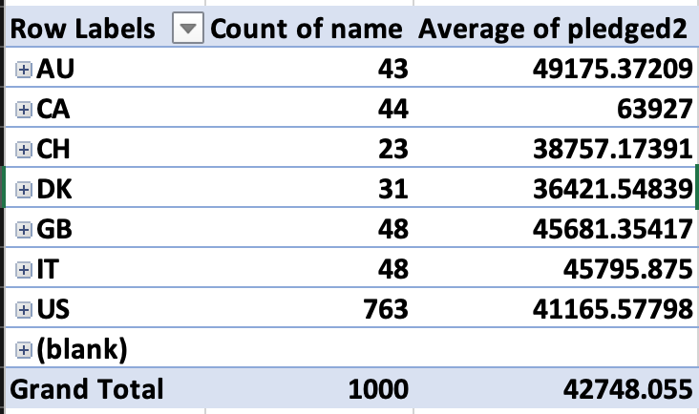

The second limitation is that the dataset is mostly made up of US crowdfunders. As indicated in the pie chart below, more than 75% of all crowdfunding projects in the current dataset were from the US. As such, the results from this dataset won’t be representative of worldwide crowdfunding projects. For example, if we want to know which crowdfunding category was the most successful, our results would be biased toward US crowdfunding projects. Therefore, it’s useful to include a pie chart to inspect the proportions of crowdfunding projects by country to determine whether we can extrapolate our results or not.

Another graph that is useful for visualisation of the dataset is a bar graph that shows the averages of backers’ count by country. For example, the bar graph below suggests that on average, it is easier to find backers for a crowdfunding project in Canada than Denmark.

**A brief and compelling justifcation of whether the mean or median better summarises the data**

Median better summarises that data because both successful and uncessful campiagns are rightly skewed by extreme values. If we use the mean to represent the data then it will be biased towards these extreme values, thereby inaccurately represents the characteristics of successful/unsuccessful campaigns. This variability makes sense because the more successful a campaign was, the more backers it had, and as such, the upper limit for the successful distribution is unlimited.